* Starting the application

1. Backend
   1. Open the application in IDE (Intellij)
   2. Create database gst, owner to postgres in PostgreSQL
   3. Start the application from main class (GstApplication)
   4. Backend application will run on default tomcat port 8080
2. UI
   1. Open the project in IDE (Visual Studio)
   2. In the terminal, run command : npm install
   3. TO start the application, run command : npm run ng serve
   4. UI Application will run on default port 4200

* UI Screens Demonstration

1. Create category screen

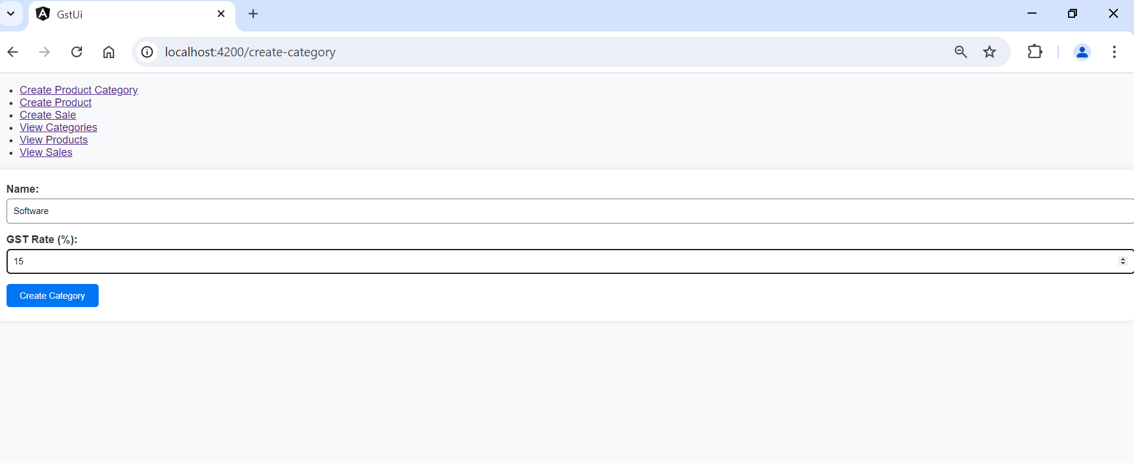

1. Category list

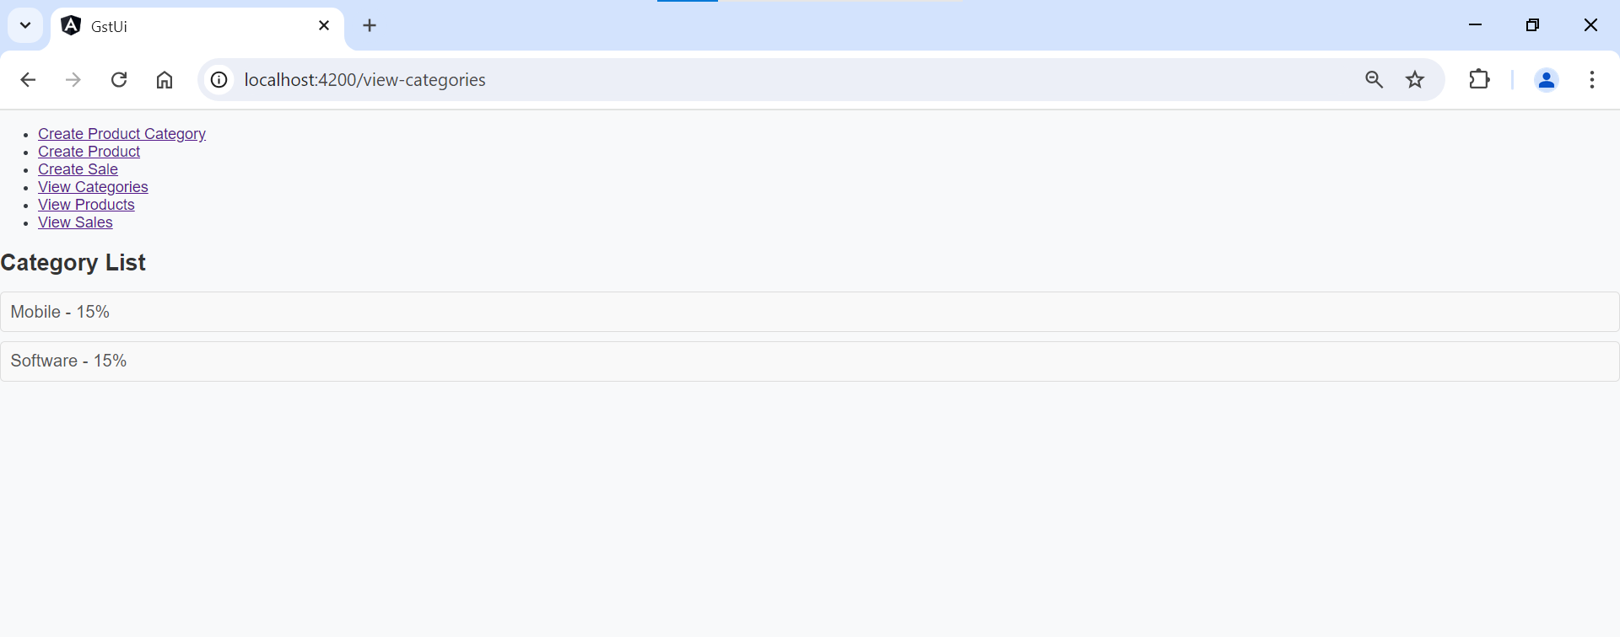

1. Create Product

1. Product List

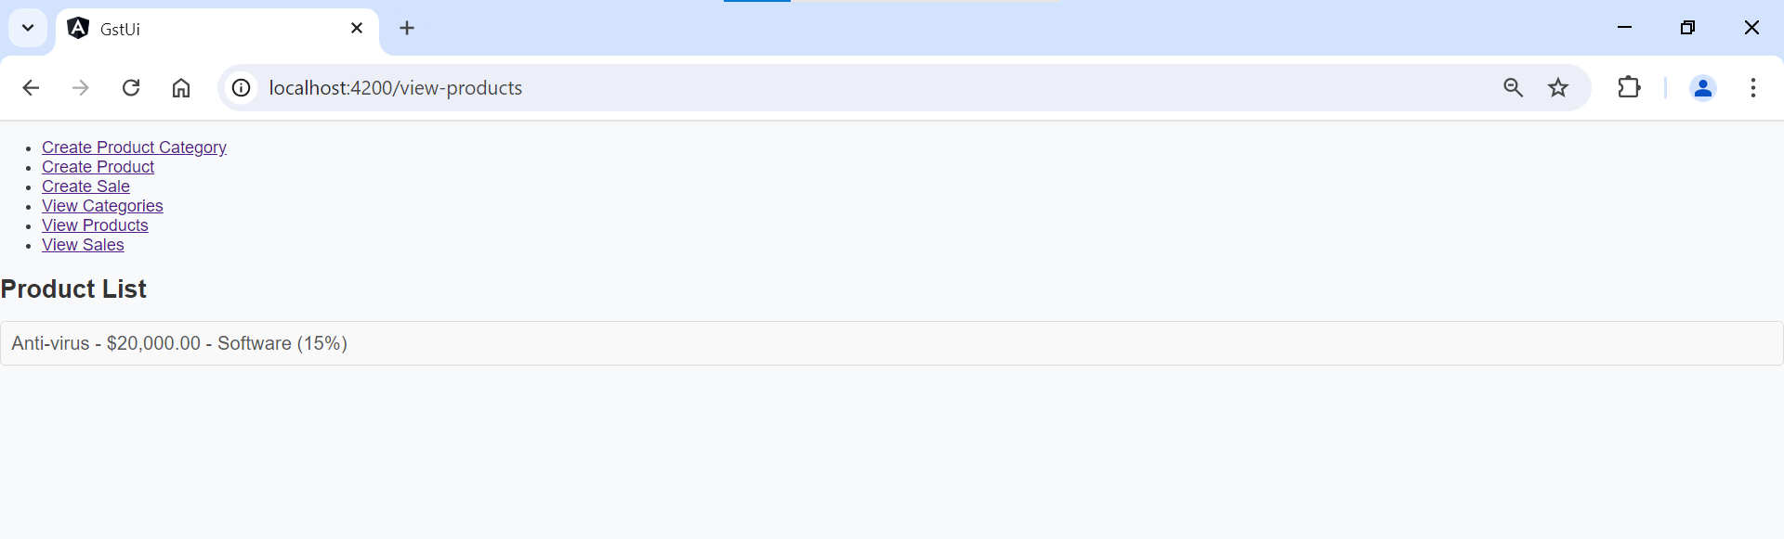

1. Create Sale

1. Sale List

